ADVANCED CYBERSECURITY CONCEPTS

CLOUD SECURITY DAY1

TASK1: List three examples of data confidentiality, availability, and integrity in the context of cloud apps you use (such as Google Drive, Spotify, or Instagram), and briefly explain how each principle applies.
1. Examples of confidentiality, availability, and integrity
The CIA triad has three important principles:
Confidentiality
Only authorized people should access private information.
Availability
Data and services should be accessible whenever users need them.
Integrity
Data should remain correct and should not be changed without permission.
Examples from cloud apps:
Principle | App | Example
Confidentiality | Google Drive | Private files are accessible only to the owner and people who have permission.
Confidentiality | Instagram | Account privacy settings help control who can see private posts.
Confidentiality | Spotify | Account credentials and personal account information are protected from unauthorized access.
Availability | Google Drive | Users can access stored files when they have an internet connection and the service is operating.
Availability | Spotify | Users can stream music when the service and network are available.
Availability | Instagram | Users can access posts, messages, and profiles when the service is working.
Integrity | Google Drive | File permissions and version history help prevent or recover unwanted changes.
Integrity | Instagram | Account security helps prevent unauthorized changes to profile information and posts.
Integrity | Spotify | Account authentication helps prevent unauthorized changes to playlists and account settings.

TASK2: Create a table listing five common cloud security threats (for example: data breach, DDoS attack, insecure APIs, account hijacking, data loss) and write one mitigation strategy for each.
2. Five common cloud security threats and their solutions
Cloud security threat | Meaning | One mitigation strategy
Data breach | Unauthorized people access private or sensitive data. | Use encryption and strong access permissions.
DDoS attack | Attackers send huge amounts of traffic to make a service unavailable. | Use DDoS protection and traffic filtering.
Insecure APIs | Weak application interfaces may allow unauthorized access. | Use API authentication, authorization, and secure testing.
Account hijacking | An attacker steals login details and takes control of an account. | Enable multi-factor authentication (MFA).
Data loss | Important files are deleted, damaged, or lost. | Maintain regular backups and test recovery.

TASK3: Sign up for a free AWS or Azure account (if you don't have one), log in to the Management Console, and take a screenshot of the dashboard showing your account name and region. Paste the screenshot into a document and label the main sections you see.
Step 1: Create a free AWS account
- Open AWS Free Tier.
- Click Create a Free Account.
- Enter your email address and account name.
- Verify your email address.
- Complete the requested contact and payment verification details.
- Choose the free/basic support option if available.
- Sign in to the AWS Management Console.
Step 2: Open the dashboard
- Sign in to AWS.
- Open the AWS Management Console home page.
- Look at the top-right corner for your account menu and selected region.
- Select a region, for example Asia Pacific (Mumbai) – ap-south-1.
- Take a screenshot of the dashboard.

Step 3: Label the main dashboard sections
You can add these labels in Word using text boxes or arrows:
Dashboard section | Purpose
AWS Services | Provides access to different AWS services.
Search bar | Helps find services quickly.
Region selector | Selects the geographical AWS region.
Account menu | Shows account and sign-in information.
Recently visited | Shows services opened recently.
AWS service shortcuts | Provides quick access to commonly used services.

TASK4: In your AWS or Azure Management Console, locate the section where you can create a new user or identity. Create a new user with only basic read permissions (no admin rights), and note the steps you took.<br><br><em><strong>Hint:</strong> In AWS, use IAM; in Azure, use Azure Active Directory.</em>
Step 1: Open IAM
- In the AWS Console search bar, type IAM.
- Open IAM – Identity and Access Management.
- Select Users from the left-side menu.
- Click Create user.
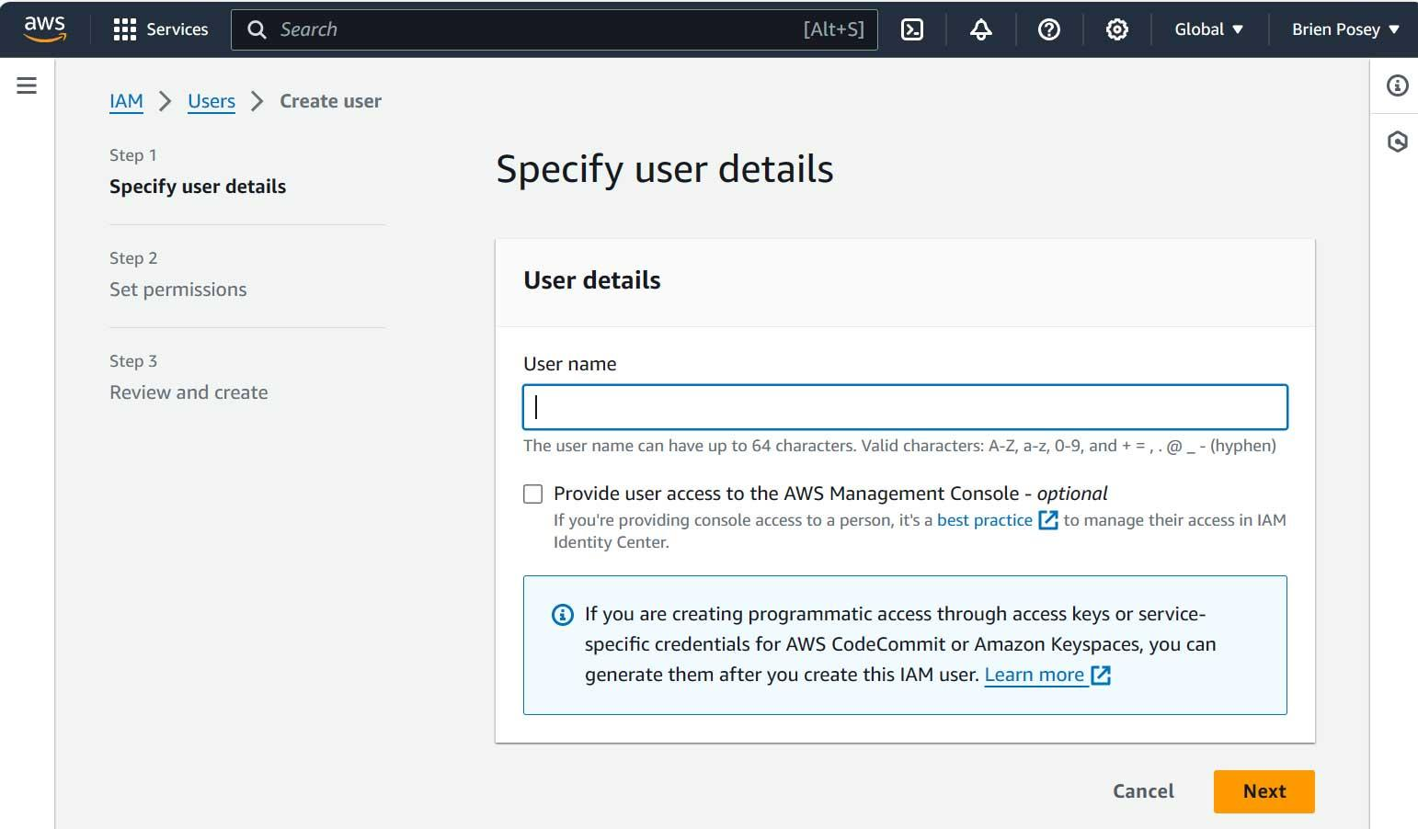
Step 2: Enter user details
- Enter a username, for example: student-readonly
- If the console asks whether to provide AWS Management Console access, enable it if you need to log in as this user for testing.
- Follow the password setup instructions.
- Click Next.

Step 3: Set read-only permissions
- Select Attach policies directly.
- Search for: ViewOnlyAccess
- Select the AWS managed policy named ViewOnlyAccess.
- Do not select AdministratorAccess.
- Click Next.
- Review the details and click Create user.
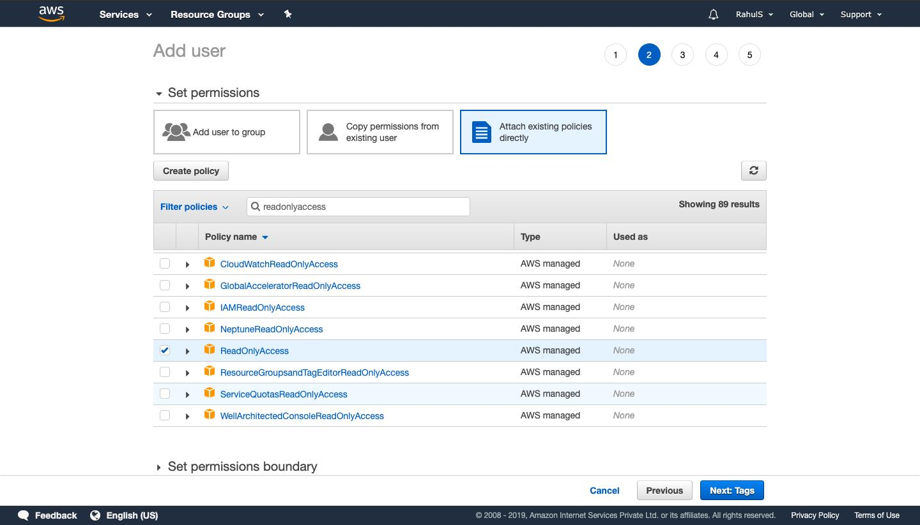
Step 4: Verify the user
- Open IAM → Users.
- Click student-readonly.
- Open the Permissions tab.
- Check that ViewOnlyAccess is attached.

TASK5: Pick one cloud security threat from your earlier table and search for a real-world incident involving this threat using Google or ChatGPT. Summarize what happened, how it was exploited, and what could have prevented it.
Threat selected: Account hijacking
Research source: Google Cloud's Mandiant threat intelligence report, published June 10, 2024.
UNC5537 Targets Snowflake Customer Instances for Data Theft and Extortion – Google Cloud
Summary (ready to write):
In 2024, a cybercriminal group called UNC5537 targeted customer accounts on the Snowflake cloud data platform. Attackers used usernames and passwords stolen through infostealer malware to enter customer accounts and steal sensitive data. Many affected accounts did not have multi-factor authentication (MFA), and some passwords had remained valid for years. This attack could have been reduced by enabling MFA, changing exposed passwords, and allowing access only from trusted network locations.

How was it exploited?
- Attackers obtained login credentials through infostealer malware.
- They used those credentials to access customer cloud accounts.
- They searched databases for valuable information.
- They copied data and attempted extortion.
What could have prevented it?
- Enable MFA on all accounts.
- Use strong, unique passwords.
- Change compromised passwords immediately.
- Restrict access to trusted IP addresses or networks.
- Monitor account activity and investigate unusual logins.

